How to take part in “Play At Home” program

- Click on the Link : http://www.sportzvillage.com/schools/playathome/ (The content is viewable on PC, mobile and tablets)
- Choose the table based on the grade your child is in. (For children of grades Nursery to 6th it is strongly recommended that there is adult supervision during the activities)

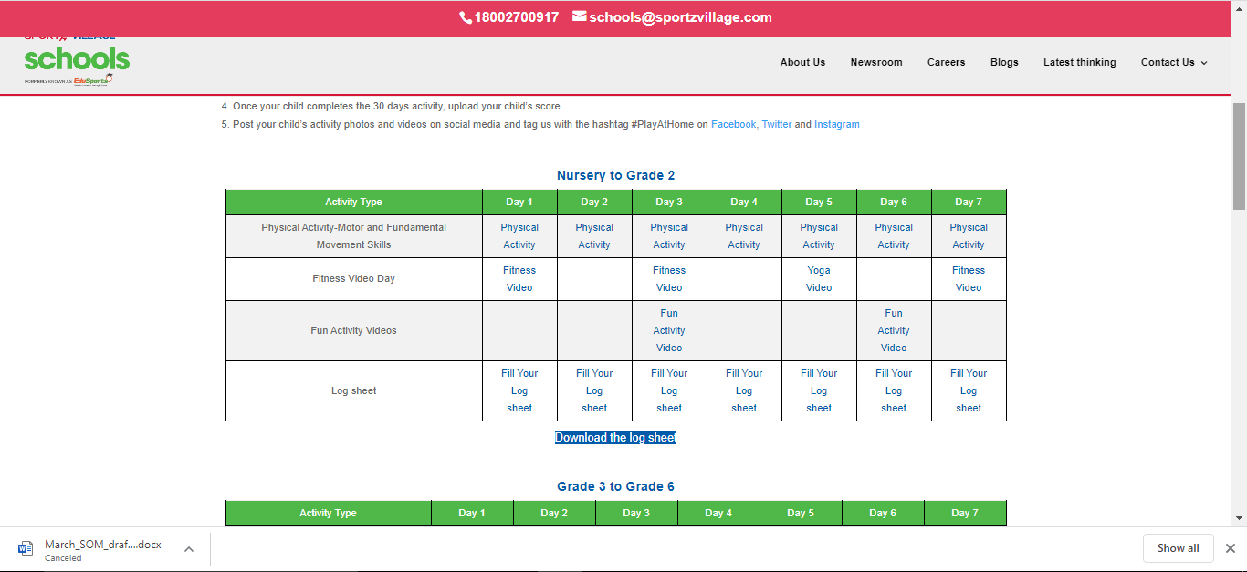

- Get your child to do the activities mentioned for the particular day . The day you start is considered Day 1
- Activity details can be seen by clicking on each of the activity text
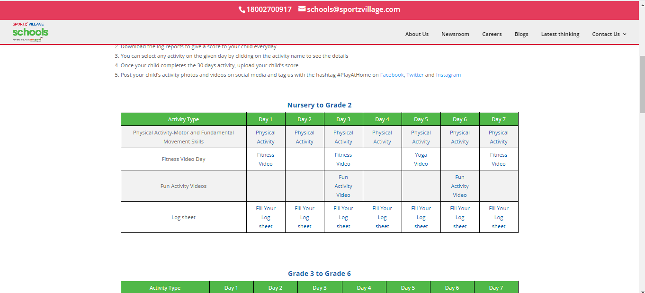

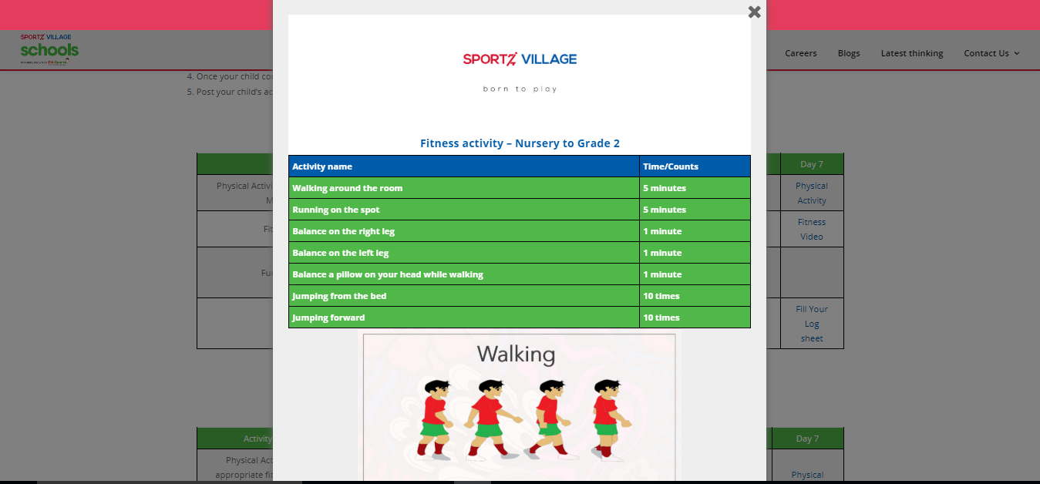

- Download the logsheet by clicking on the button
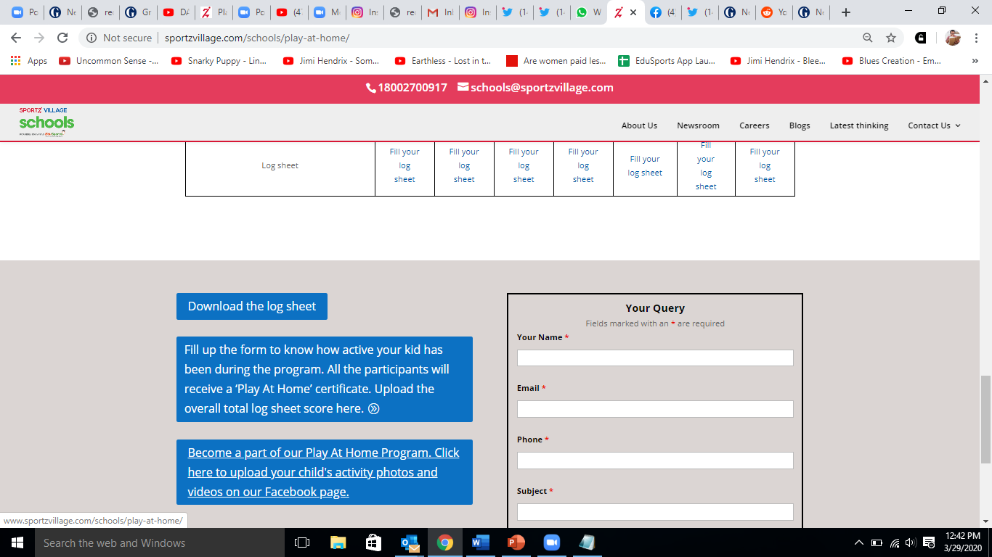

- Fill in the score in the log sheet based on the activities conducted. You can use the log sheet to calculate the score at the end of the 30-day period
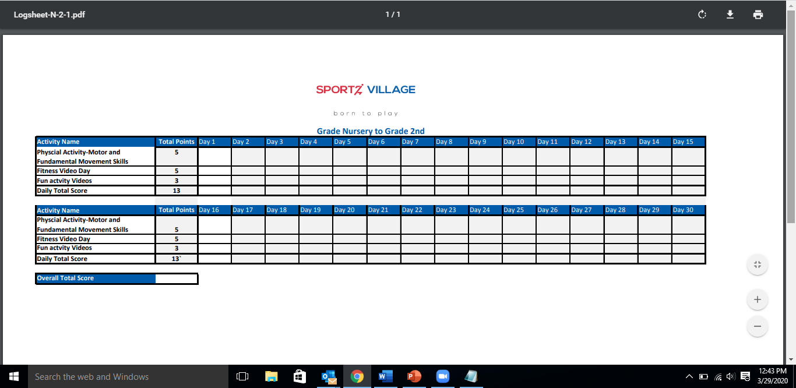

- You can submit your child’s score at the end of the 30-day period by clicking on the highlighted button and filling in the relevant details.

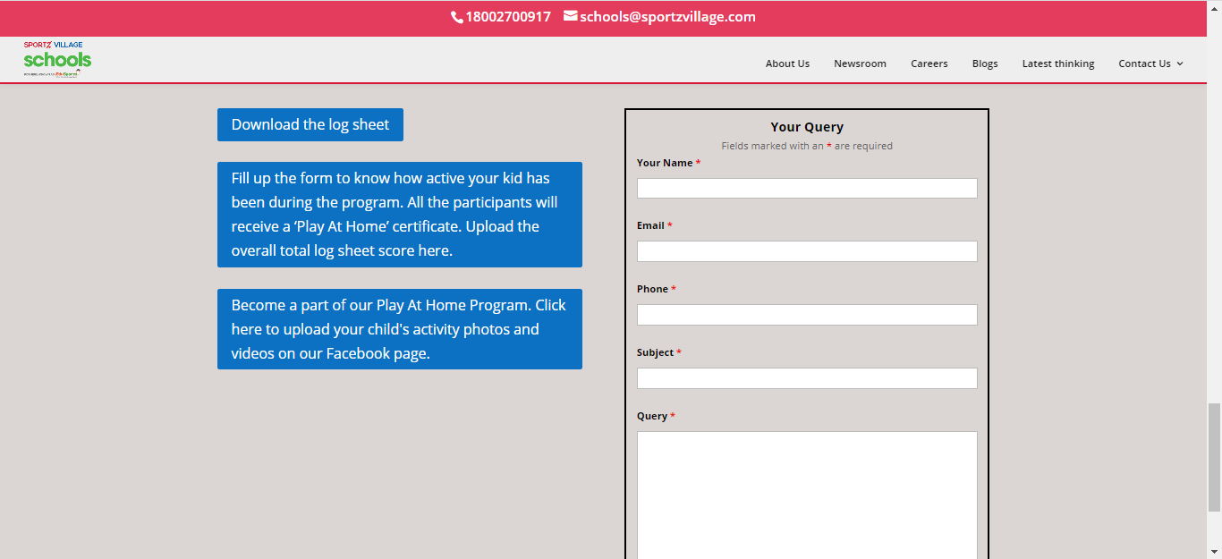

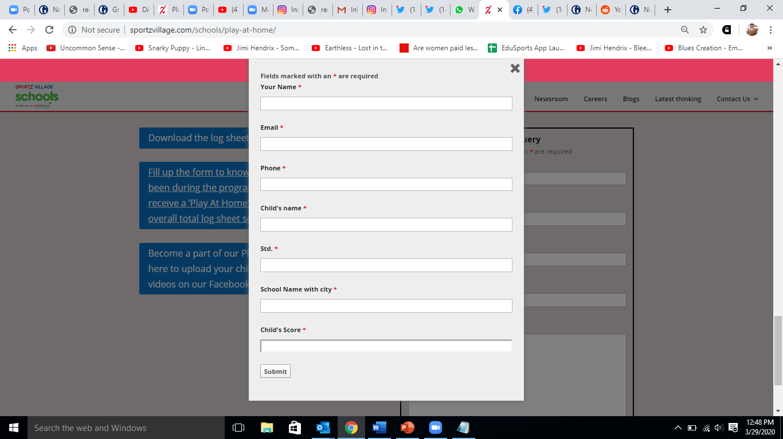

- You can upload your child doing the physical activity on the ‘Sportz Village’ Facebook page or on your own social media handles using #playathome. (Videos to be uploaded only with the consent of the parent). You will be awarded a digital certificate on submission of your child’s score.
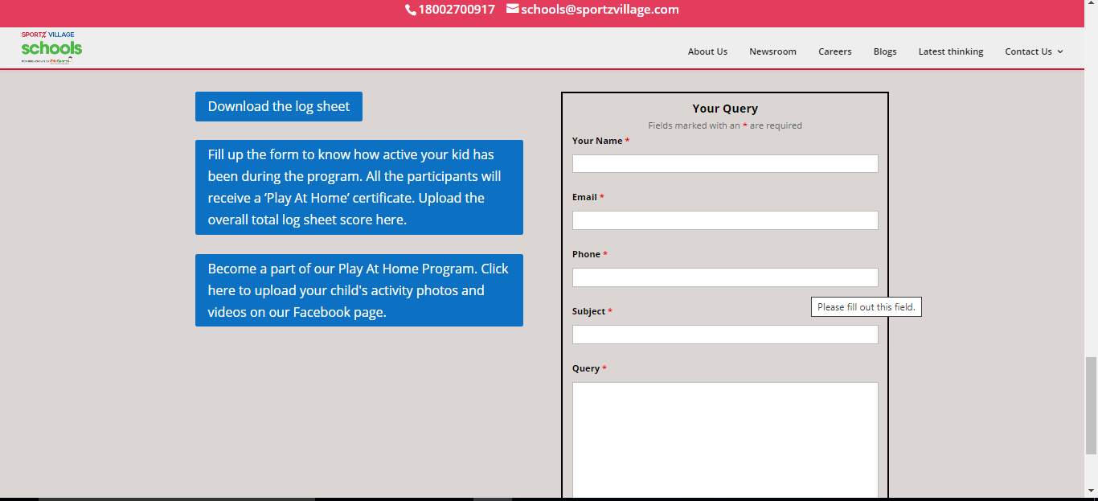

- For any Queries please write to schools@sportzvillage.com or call 981640941/9871199639

